[Ascent -- Project](https://ascent.cysun.org/project/project/view/230)

Using NASA’s ION-DTN to build an email system.

# Simulation and Limitation Analysis of Modern Delay-Tolerant Email

## How the traditional email systems work

The MUA is the client App, like Thunderbird. These in the box are server-side App, like Postfix and Dovecot.

Alice wrote an email in Thunderbird → Thunderbird hands it to the server → The server delivers it to the recipient’s server → The recipient’s Thunderbird picks it up so Bob can read it.

## 图示 AI 生成的内容可能不正确。

**Postfix**

**Dovecot**

**Dovecot**

**Postfix**

Of course, before the MTA sends the email to the next mail server, it first needs to query the DNS. Then, it uses the SMTP protocol to deliver the email.

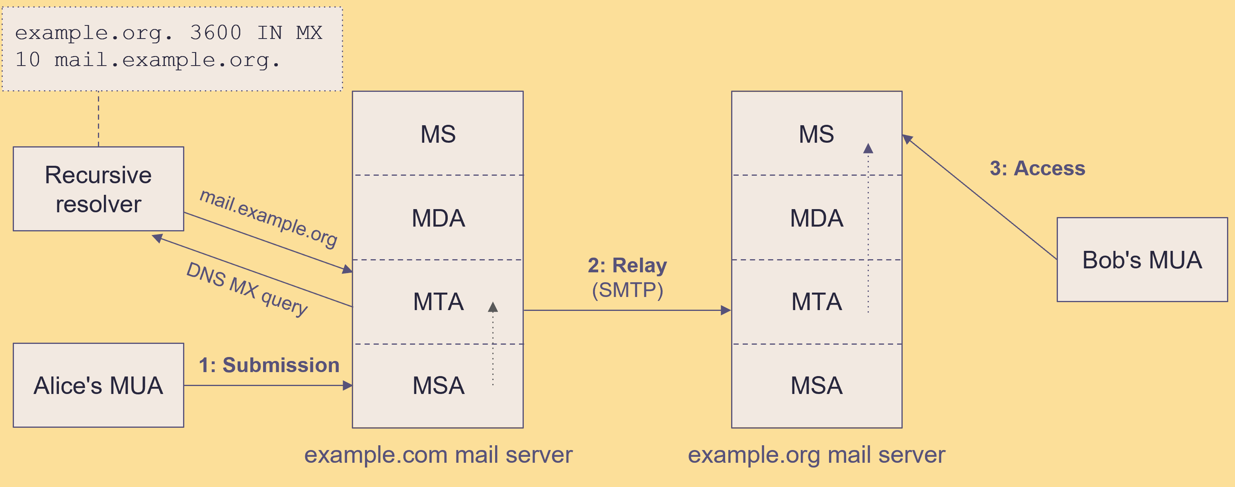

## The features of space networks

Since the distance between planets is really huge (it takes light several minutes to travel from Earth to Mars), we need a lot of satellites in between to pass along the signal. Plus, these satellites are always moving, so the network can sometimes break the signal. Because of this, space networks usually have two main features: **high delays** and **frequent disruptions**



**3~22 min**

## Why don’t traditional email systems work?

Traditional email uses SMTP to send messages, and SMTP itself is based on TCP/IP. They rely on low-latency, uninterrupted networks, because their communication process relies on multiple handshakes. However, space networks have **high delays** and **frequent disruptions**, making these traditional systems unreliable in such environments.

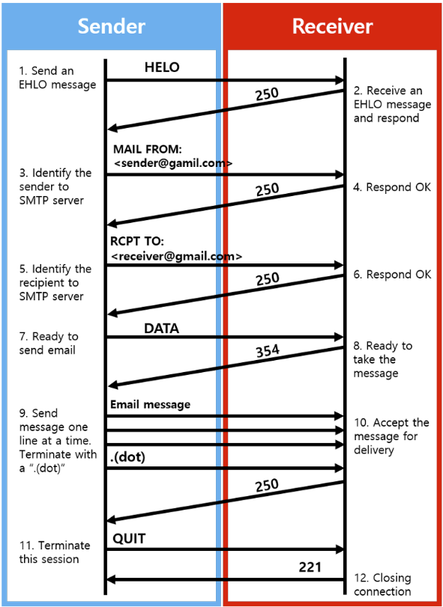

Many Round-Trip in SMTP

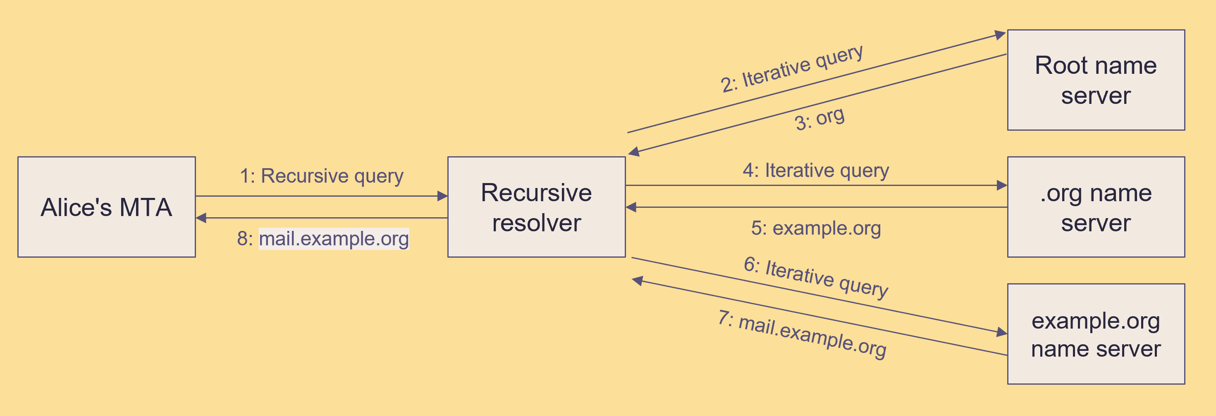

Many Round-Trip in DNS query

## How can we solve the problems caused by space networks?

DTN (Delay Tolerant Network) uses “**store and forward**” technology. This means when the network is disconnected, it will temporarily save the data packets. Once the connection is back, it sends the packets to the next node.



Store and Forward

**The architecture of the DTN**

DTN adds a “bundle” layer on top of the transport layer. This bundle layer enables the “store and forward” feature.

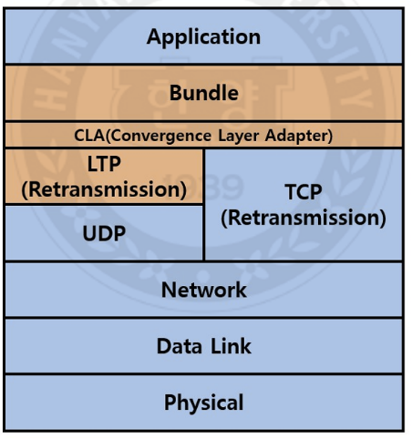

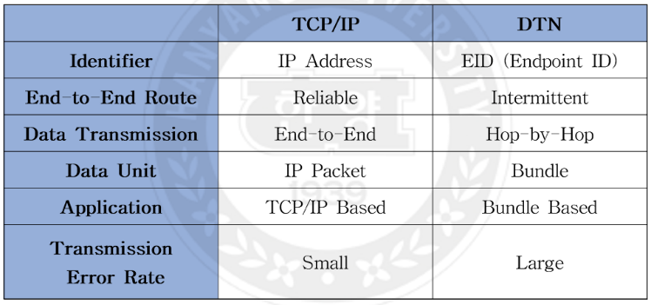

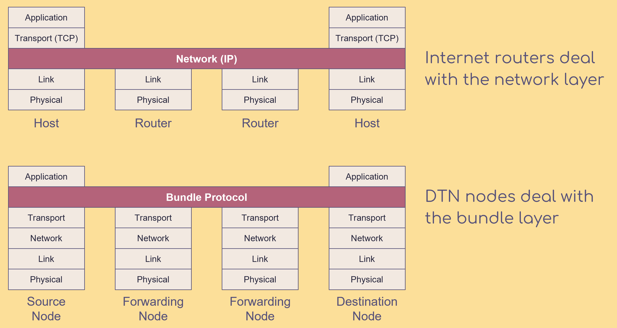

## How to combining the email system with DTN ?

[draft-johnson-dtn-interplanetary-smtp-01 - A method for delivery of SMTP messages over Bundle Protocol networks.](https://datatracker.ietf.org/doc/draft-johnson-dtn-interplanetary-smtp/)

In Johnson’s draft, he gives a solution. He suggests that every planet has its own traditional internet (like the internet we use on Earth), and DTN is used to connect the different planets together. The DTN network and the traditional internet on each planet are joined using gateways.

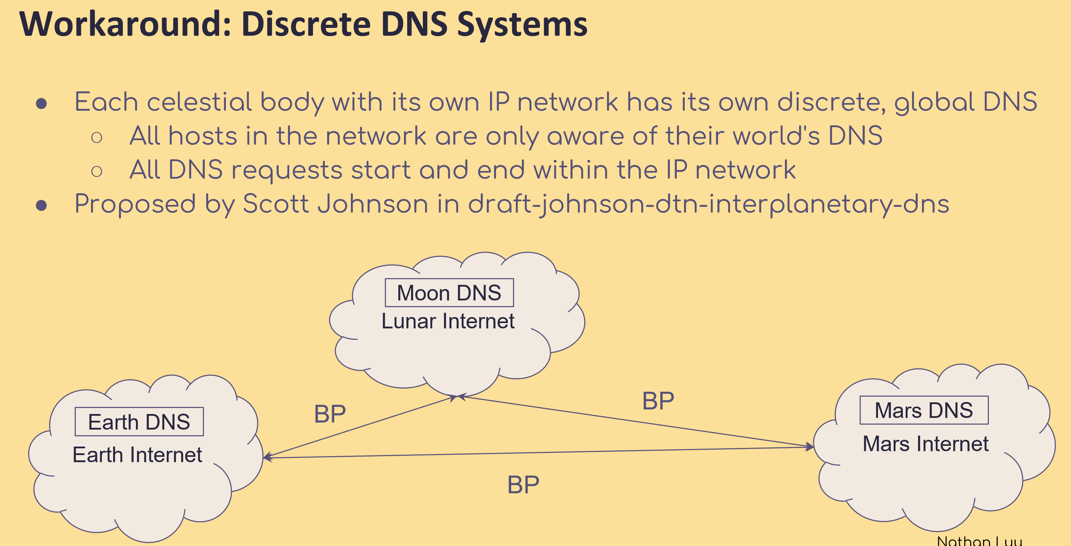

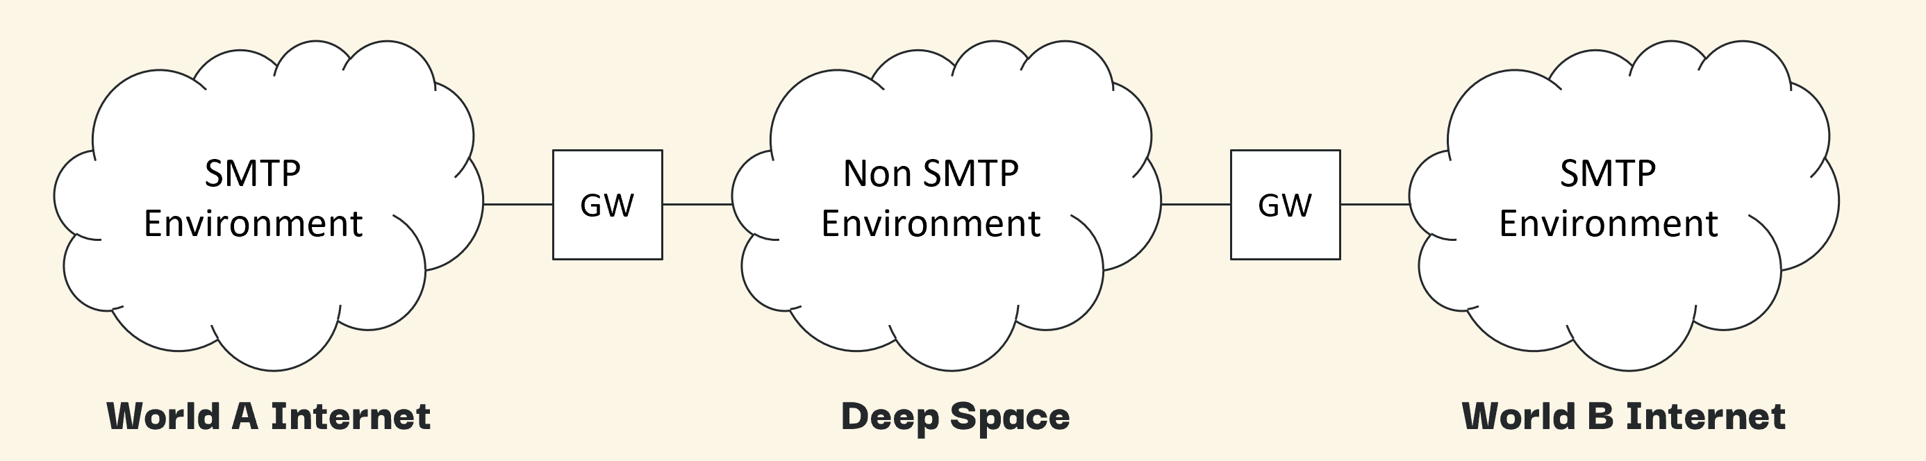

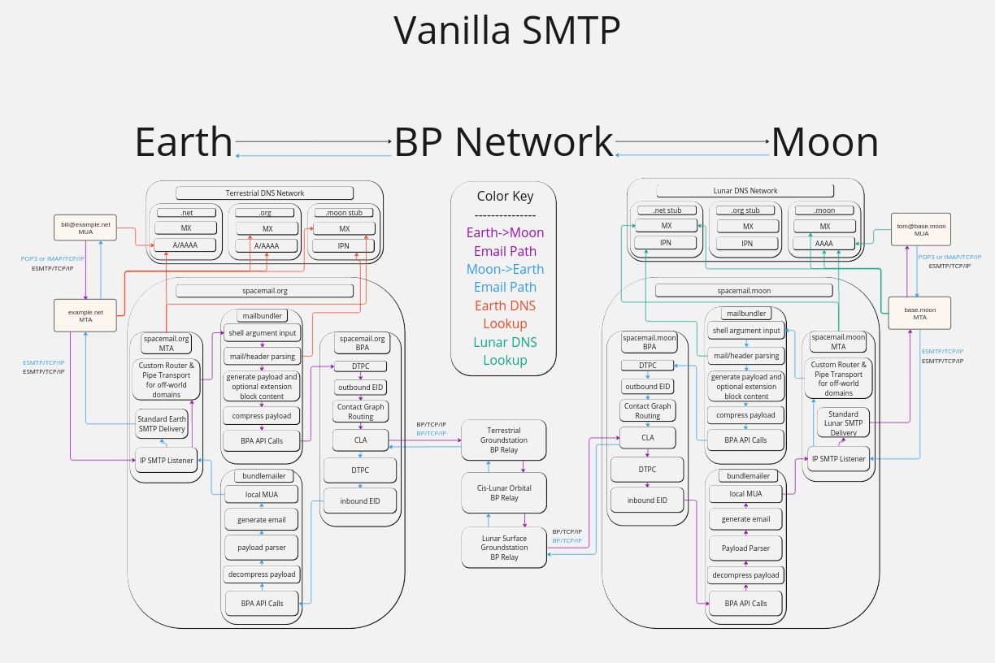

Gateway

[draft-blanchet-dtn-email-over-bp-05 - Encapsulation of Email over Delay-Tolerant Networks(DTN) using the Bundle Protocol](https://datatracker.ietf.org/doc/draft-blanchet-dtn-email-over-bp/)

To avoid the many handshakes required by SMTP, Blanchet suggested a new protocol called Batch SMTP. This protocol puts all the information that would normally be sent back and forth many times into one big message. So, you only need to send the message once, instead of going back and forth several times. Of course, for this protocol to work, both sides need to be trusted nodes. For example, in this case, the gateways are trusted, so they can use Batch SMTP to communicate.

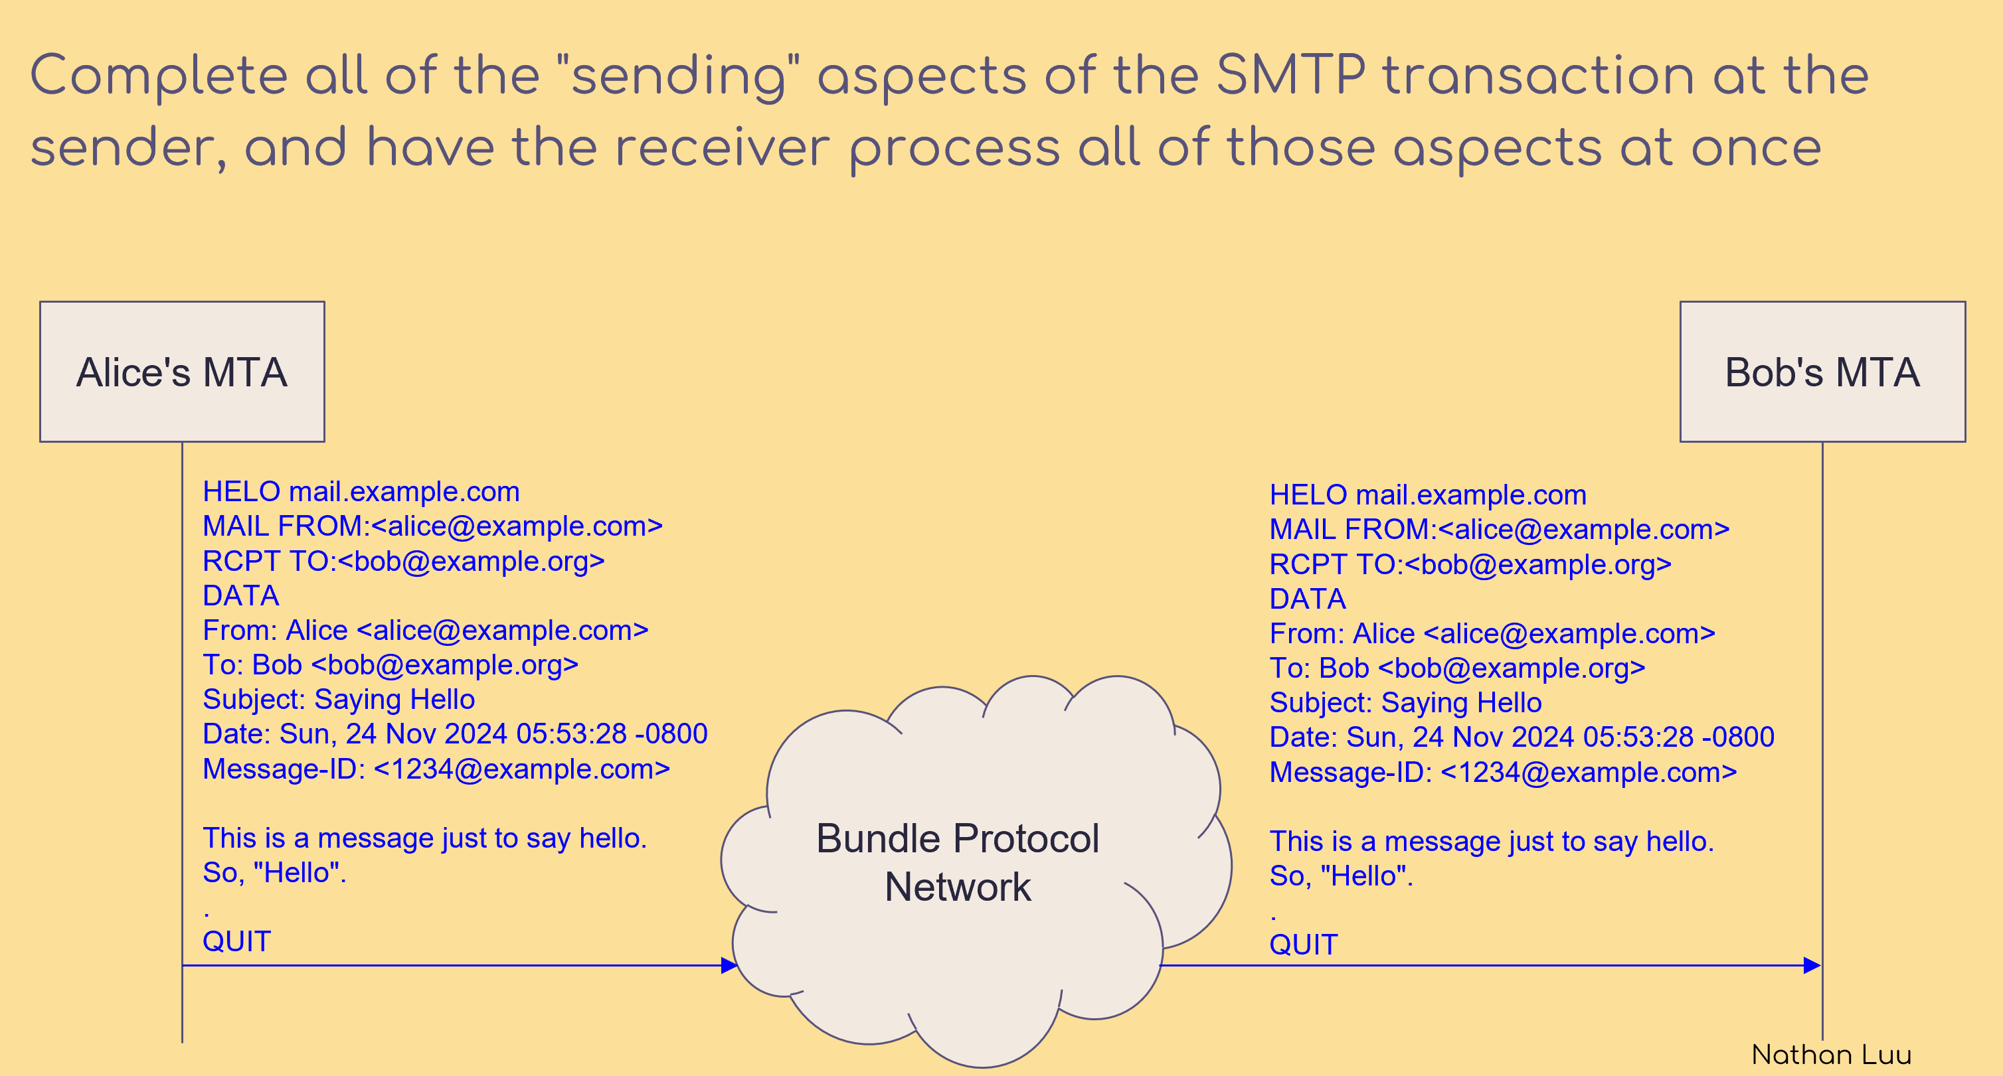

Batch SMTP (Both sides are trusted nodes, so there’s no need for extra handshakes.)

[draft-johnson-dtn-interplanetary-dns-04 - An Interplanetary DNS Model](https://datatracker.ietf.org/doc/draft-johnson-dtn-interplanetary-dns/)

To make DNS work between different planets, Johnson suggests that each planet has its own top-level domains. When you try to look up a domain name that belongs to another planet, the DNS server just gives you the IP address the gateway. Once your data packet arrives at the gateway on the other planet, that gateway does another DNS lookup to find the final address and forwards the data.

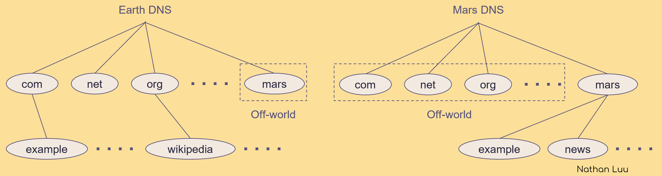

Name servers for off-world domains are not "real". Must be gateways.

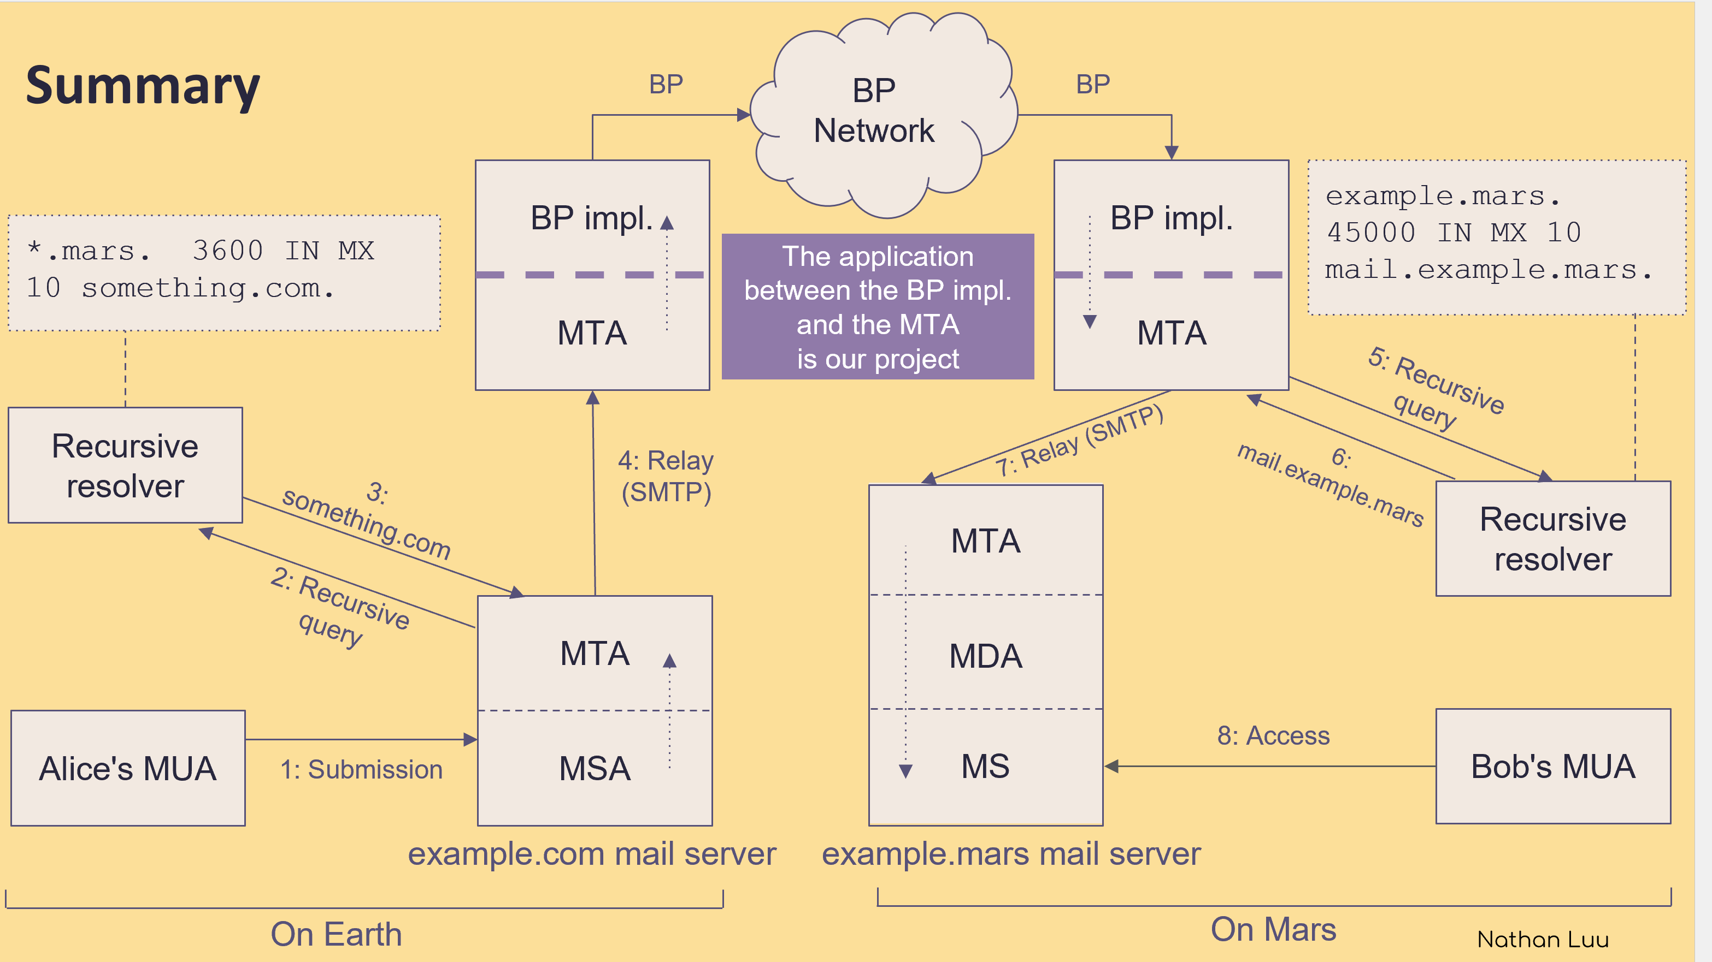

[Ascent -- Project](https://ascent.cysun.org/project/project/view/230)

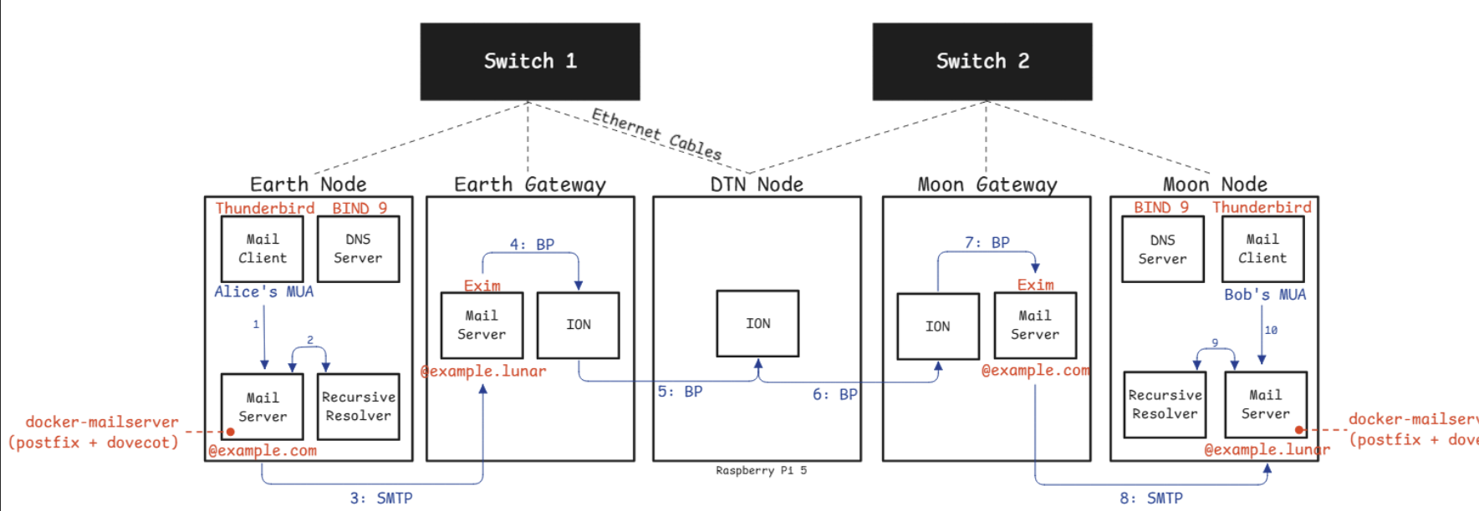

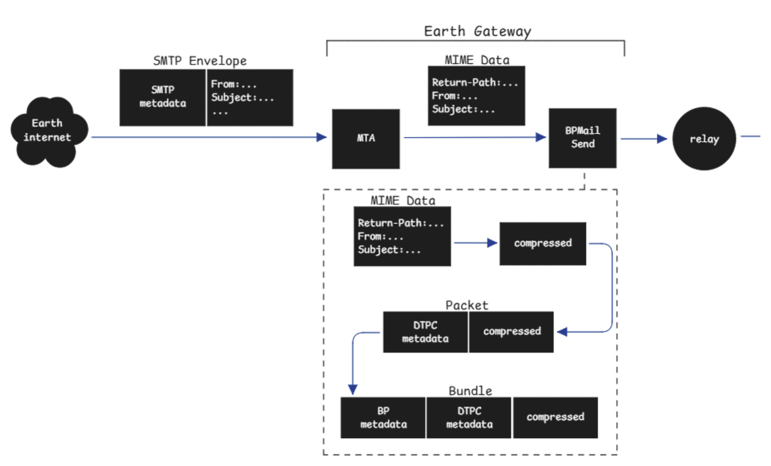

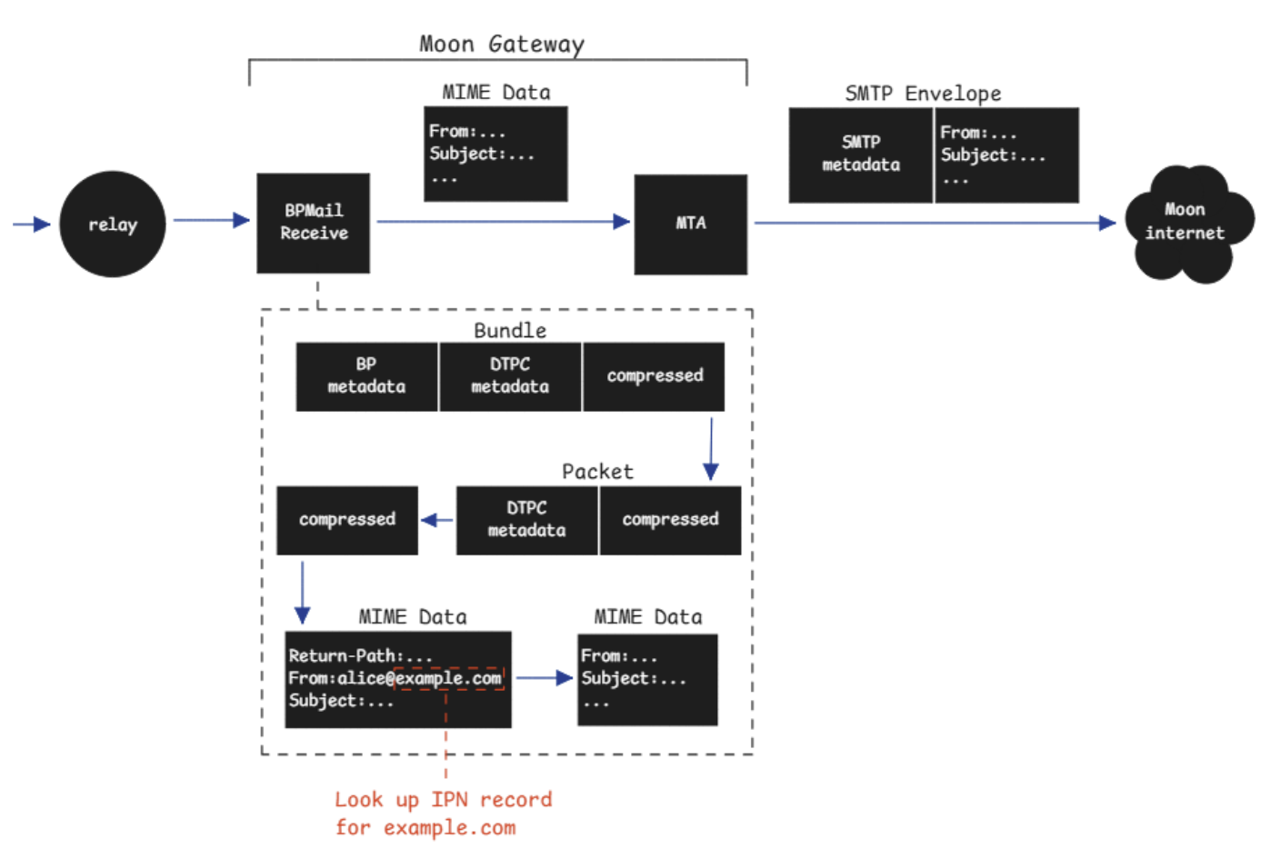

My implementation

我的实现的模拟太空网络用了Docker容器来代表不同的星球上的邮件服务器。中间又加了一个容器来模拟太空网络的延迟。最下面的docker容器模拟用户使用的客户端。我简化了DNS查询的流程，仅使用hosts文件来指定目标服务器地址。以下是一封邮件收发的大致流程。首先邮件从地球客户端上的Thunderbird发给邮件服务器，邮件服务器上的Postfix接收到发件请求后把邮件投递给BPMailSend这个gateway程序。Gateway受到邮件后，把他封装成batch SMTP格式，然后再装入一个bundle包，通过ION-DTN这个延迟容忍网络发给月球。经过1秒延迟后，另一月球上的gateway BPMailRecv收到了这个bundle，然后拆出里面的邮件信息，在重新投递给邮件服务器Postfix，最终投递到用户手里。与Johnson的假设不同的是，这里的收件人并没有在月球上，而是恰好在地球旅行。此时客户端与邮件服务器的通信也有1秒延迟。但是与SMTP发邮件不同的是，收件用的是IMAP协议，既没有走ION-DTN网络，也需要多次TCP握手建立连接。这时候的收件延迟就变得特别高。

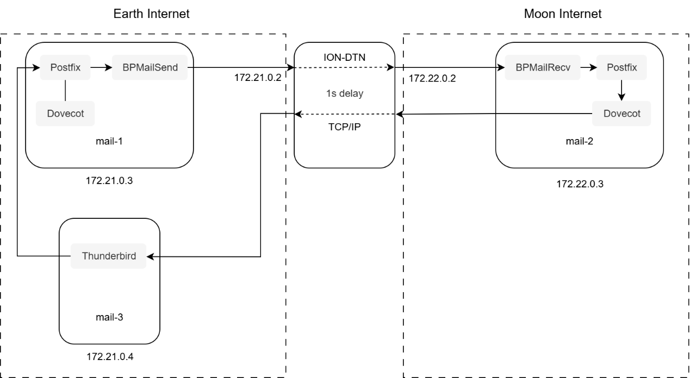

Deep Space Email Retrieval Delay Performance Experiment

Background

Johnson’s solution (draft-johnson-dtn-interplanetary-smtp) and the *SMTP Gatewaying Across Delay Tolerant Networks* project have reduced the impact of interplanetary delay and disruption on email delivery. They efficiently deliver SMTP emails via DTN to mailbox on other planets.

However, problems arise when users travel to another planet and want to check their emails: their messages are still delivered to their original planet’s mailbox, but the process of retrieving emails is still performed using the traditional TCP-based IMAP protocol. Syncing mail folders and confirming each message are still greatly affected by the high interplanetary latency.

Scenario Description

First, 1,000 emails (Body: “Hello”) are sent to the mail-2 server on the Moon. It means the recipient on the Moon has already successfully received their emails on the lunar email server.

Later, the recipient travels to Earth and wants to check these emails there. So, the recipient uses the Thunderbird client on mail-3 to retrieve these new emails via the IMAP protocol.

I test different physical one-way network delays (0s/1s/2s/5s), and record the total time required to retrieve all emails (overall retrieval time). The results are shown in the following table.

|  |  |  |  |
| --- | --- | --- | --- |
| Body | number of emails | Delay | overall retrieval time |
| Hello | 1000 | 0s | 19s |
| Hello | 1000 | 1s | 33s |
| Hello | 1000 | 2s | 64s |
| Hello | 1000 | 5s | 153s |

Findings

The overall download time increases linearly with network delay. When the delay is 5 seconds, the email client becomes very sluggish and is almost unusable.

To improve the email retrieval experience in deep space, it is necessary to introduce a DTN retrieval agent or a batch synchronization mechanism during the email retrieval process.